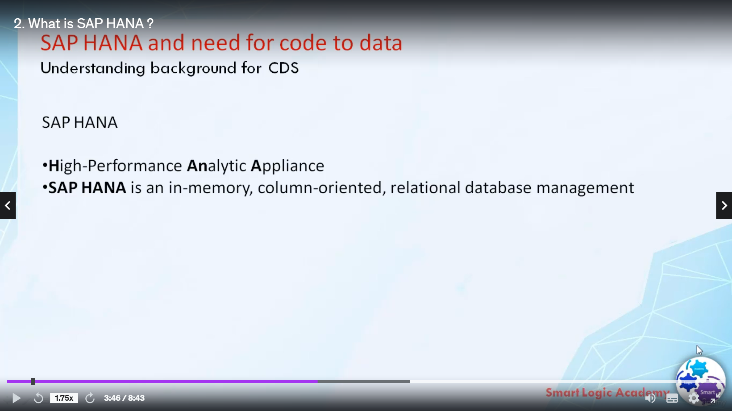

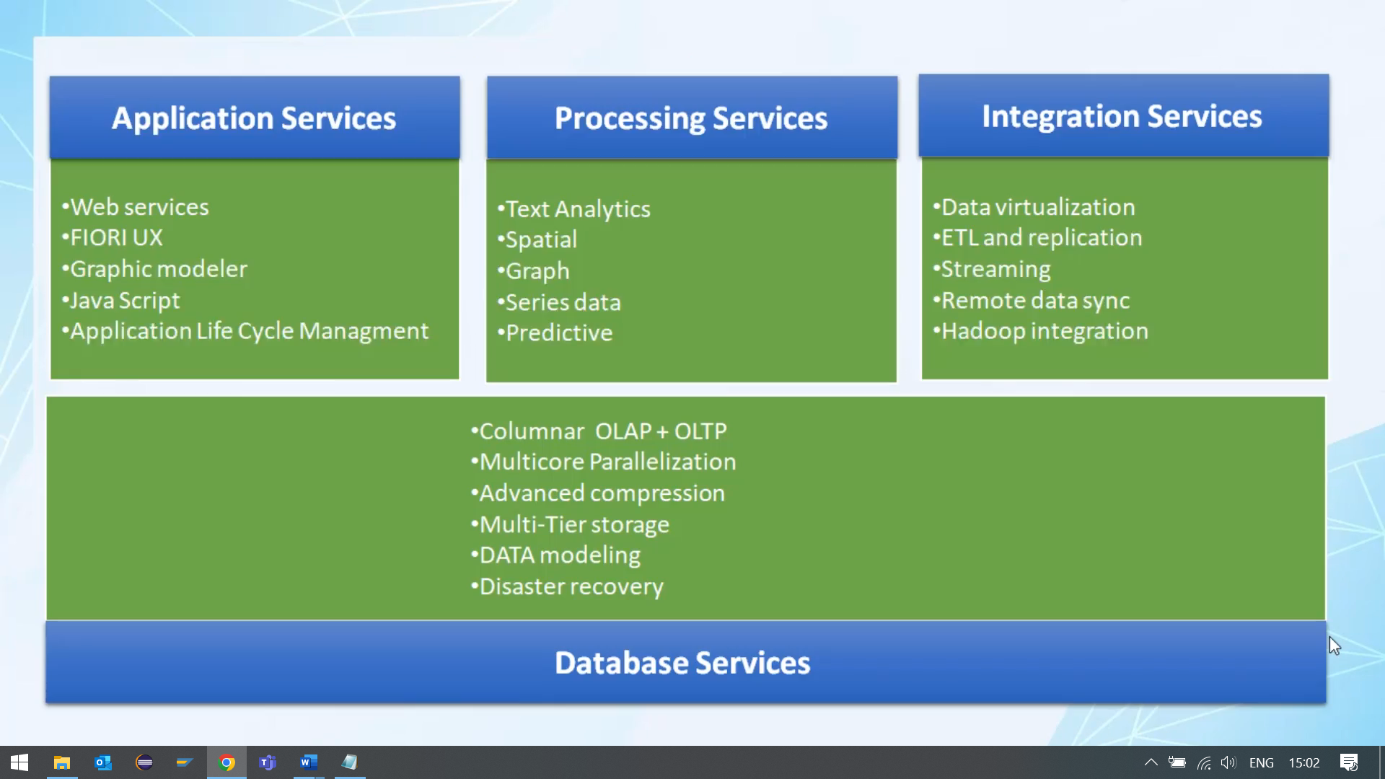

SAP HANA is an in-memory, column-oriented, a relational database management system that allows processing of massive amount of real time data in short time.

HANA stands for the high-performance analytic appliance. SAP HANA is not just a database but its an the appliance that combines the latest development in hardware and software technology and change the way of developing and executing applications.

In the definition, relational database refers to a database that stores the data in structured format using rows and columns. Relational database management system is a software system that enables users to define, create, maintain and control access to the database.

An in-memory database is a relational database management system

that primarily relies on main memory for data storage. It is contrasted with the traditional database management a system that employs a disk storage mechanism.

In-memory databases are faster than disk optimized databases because disk access is much slower than memory access and that's why SAP Hana is so fast as compared to any other database.

A column-oriented database stores each column continuously, that is in memory each column will be stored in sequential blocks. By storing data in the columns rather than rows the database can more precisely access the data it needed to answer a user query rather than scanning and discarding the unwanted data in rows.

With SAP HANA, SAP combines the latest development in hardware and software technology to provide state of the art in-memory database.

its primary function as a database server is to store and retrieve data as requested by an application. However, SAP HANA is much more the than a database.

SAP HANA platform combines all key components that can be used to power any application. These components include database, data processing, application development tooling, lifecycle management, and data integration.

From the diagram shown in this slide you can easily observe that SAP HANA not only provides database services but it also provide you application services, processing services, and integration services.

Let's take an example, imagine an application that allows a project manager to quickly check that all the team members have completed their timesheets this application could be developed as a web application where only web browser and SAP HANA is required and no application server is needed.

This is possible because SAP can handle business logic as well as database services. SAP Hana has its own building application server. Hence SAP HANA provides full development environment with everything the developer needs at a design time and at run-time.

now let's move on and see what the different processing services are offered by SAP HANA. SAP HANA can handle as many new types of data this includes text, special, graphics and many more.

SAP HANA provides native in-memory engines that process all this type of data into your time and also commands them in a new and innovative applications.

For example, you can create an application that provides summary of customer feedbacks based on an aggregation of social media comments.

This is possible because SAP HANA can access data from social networks such as Facebook, Twitter and LinkedIn.

It also can access Big Data for example Hadoop.

SAP HANA can access data from any type of source systems such as SAP S/4 HANA , SAP BW. It also comes with the capability of accessing data from sensors for building IoT (internet of things) applications.

So all of these are processing services provided by SAP HANA.

Let's see integration services provided by SAP HANA.

SAP HANA has its own built-in ETL tool which provides extraction, transformation and loading capabilities. This means that integrating and cleansing data is possible without the need to implement any other tools.

In SAP HANA data can be physically loaded either in real time or in a batch processes, data can access virtually from a remote source to obtain a live view of data without loading that data.

In SAP HANA data can be loaded from files, databases, continuous streams or occasionally connected sources. So these are all the integration services provided by SAP HANA.

So now you must have understood that SAP HANA is not just a database but it's an appliance which provides database services, applications services, processing services, and integration services.